1. **Conceptual data model: Entity-Relation Diagram (ERD)**

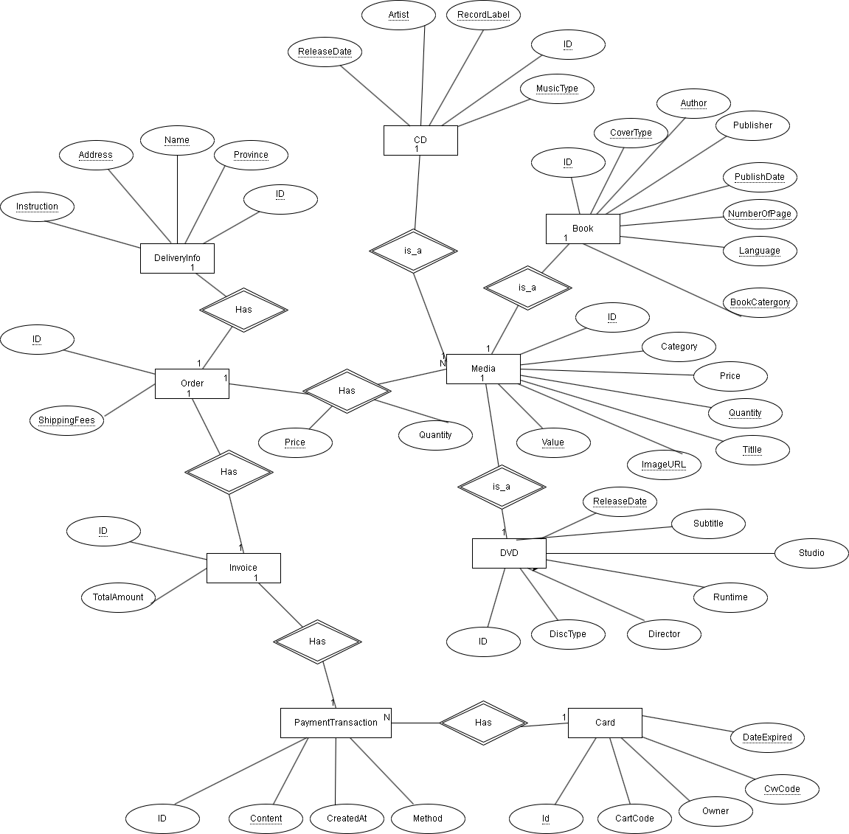

1. **Logical data model: Database Design Diagram**

1. **Physical data model:**
   1. **Table DeliveryInformation**

|  |  |  |  |  |  |  |
| --- | --- | --- | --- | --- | --- | --- |
| **STT** | **PK** | **FK** | **Column Name** | **Data Type** | **Mandatory** | **Description** |
| **1** | x |  | id | INT | Yes | ID, auto increment |
| **2** |  |  | address | VARCHAR(100) | Yes | Delivery address |
| **3** |  |  | province | VARCHAR(45) | Yes | Provinces |
| **4** |  |  | name | VARCHAR(45) | Yes | Receiver name |
| **5** |  |  | phone | VARCHAR(20) | Yes | Contact number |
| **6** |  |  | shipping_method | INT | Yes | Shipping Method (normal: 0, rush: 1) |
| **7** |  |  | instructions | VARCHAR(200) | No | Delivery Instructions |

* 1. **Table Media**

|  |  |  |  |  |  |  |
| --- | --- | --- | --- | --- | --- | --- |
| **STT** | **PK** | **FK** | **Column Name** | **Data Type** | **Mandatory** | **Description** |
| **1** | x |  | id | INT | Yes | ID, auto increment |
| **2** |  |  | price | INT | Yes | Current price |
| **3** |  |  | category | VARCHAR(45) | Yes | Media type (CD, DVD, Book, LP) |
| **4** |  |  | value | INT | Yes | Product value |
| **5** |  |  | quantity | INT | Yes | Number of products |
| **6** |  |  | title | VARCHAR(100) | Yes | Product name |
| **7** |  |  | imageUrl | VARCHAR(200) | No | Product image path |

* 1. **Table CD**

|  |  |  |  |  |  |  |
| --- | --- | --- | --- | --- | --- | --- |
| **STT** | **PK** | **FK** | **Column Name** | **Data Type** | **Mandatory** | **Description** |
| **1** |  | x | id | INT | Yes | ID, same ID of Media of which category is CD |
| **2** |  |  | artist | VARCHAR(45) | Yes | Artist’s name |
| **3** |  |  | record_label | VARCHAR(45) | Yes | Record Label |
| **4** |  |  | music_type | VARCHAR(45) | Yes | Music genres |
| **5** |  |  | track_list | VARCHAR(200) | No | Track list songs |
| **6** |  |  | release_date | DATETIME | No | Release Date |

* 1. **Table Book**

|  |  |  |  |  |  |  |
| --- | --- | --- | --- | --- | --- | --- |
| **STT** | **PK** | **FK** | **Column Name** | **Data Type** | **Mandatory** | **Description** |
| **1** |  | x | id | INT | Yes | ID, same ID of Media of which category is Book |
| **2** |  |  | author | VARCHAR(45) | Yes | Author’s name |
| **3** |  |  | cover_type | VARCHAR(45) | Yes | Cover Type |
| **4** |  |  | number_of_pages | INT | Yes | Page number |
| **5** |  |  | language | VARCHAR(45) | Yes | Language |
| **6** |  |  | book_category | VARCHAR(45) | Yes | Type of Book |
| **7** |  |  | publisher | VARCHAR(100) | Yes | Publishing house |
| **8** |  |  | publish_date | DATETIME | Yes | Date of publishing |

* 1. **Table DVD**

|  |  |  |  |  |  |  |
| --- | --- | --- | --- | --- | --- | --- |
| **STT** | **PK** | **FK** | **Column Name** | **Data Type** | **Mandatory** | **Description** |
| **1** |  | x | id | INT | Yes | ID, same ID of Media of which category is DVD |
| **2** |  |  | director | VARCHAR(45) | Yes | Director’s name |
| **3** |  |  | disk_type | VARCHAR(45) | Yes | Disc Type |
| **4** |  |  | subtitle | VARCHAR(45) | Yes | Subtitles |
| **5** |  |  | studio | VARCHAR(45) | Yes | Manufacturer |
| **6** |  |  | language | VARCHAR(45) | Yes | Language |
| **7** |  |  | runtime | INT | Yes | Duration |
| **8** |  |  | release_date | DATETIME | Yes | Release Date |

* 1. **Table LP**

|  |  |  |  |  |  |  |
| --- | --- | --- | --- | --- | --- | --- |
| **STT** | **PK** | **FK** | **Column Name** | **Data Type** | **Mandatory** | **Description** |
| **1** |  | x | id | INT | Yes | ID, same ID of Media of which category is LP |
| **2** |  |  | artist | VARCHAR(45) | Yes | Artist’s name |
| **3** |  |  | record_label | VARCHAR(45) | Yes | Record Label |
| **4** |  |  | music_type | VARCHAR(45) | Yes | Music genres |
| **5** |  |  | track_list | VARCHAR(200) | Yes | Track list songs |
| **6** |  |  | release_date | DATETIME | Yes | Release Date |

* 1. **Table Order**

|  |  |  |  |  |  |  |
| --- | --- | --- | --- | --- | --- | --- |
| **STT** | **PK** | **FK** | **Column Name** | **Data Type** | **Mandatory** | **Description** |
| **1** | x |  | id | INT | Yes | ID, auto increment |
| **2** |  |  | shipping_fee | DOUBLE | Yes | Shipping fee |
|  |  | x | delivery_info_id | INT | Yes | Delivery Information ID |

* 1. **Table Order_Media**

|  |  |  |  |  |  |  |
| --- | --- | --- | --- | --- | --- | --- |
| **STT** | **PK** | **FK** | **Column Name** | **Data Type** | **Mandatory** | **Description** |
| **1** | x |  | id | INT | Yes | ID, auto increment |
| **2** |  | x | media_id | VARCHAR(100) | Yes | Media ID |
| **3** |  | x | order_id | VARCHAR(45) | Yes | Order ID |
| **4** |  |  | price | DOUBLE | Yes | Selling price |
| **5** |  |  | quantity | INT | Yes | Number of ordered item |

* 1. **Table Invoice**

|  |  |  |  |  |  |  |
| --- | --- | --- | --- | --- | --- | --- |
| **STT** | **PK** | **FK** | **Column Name** | **Data Type** | **Mandatory** | **Description** |
| **1** | x |  | id | INT | Yes | ID, auto increment |
| **2** |  |  | total_amount | INT | Yes | Totals of items |
| **3** |  |  | total_price | DOUBLE | Yes | Total of price (include VAT) |
| **4** |  | x | order_id | INT | Yes | Order ID |

* 1. **Table PaymentTransaction**

|  |  |  |  |  |  |  |
| --- | --- | --- | --- | --- | --- | --- |
| **STT** | **PK** | **FK** | **Column Name** | **Data Type** | **Mandatory** | **Description** |
| **1** | x |  | id | INT | Yes | ID, auto increment |
| **2** |  |  | amount | DOUBLE | Yes | Transaction Money |
| **3** |  |  | content | VARCHAR(100) | Yes | Transaction contents |
| **4** |  |  | method | VARCHAR(45) | Yes | Payment Methods |
| **5** |  |  | transaction_time | DATETIME | Yes | Date of creation a transaction |
| **6** |  |  | error_message | VARCHAR(100) | Yes | Message of error |
| **7** |  | x | card_id | INT | Yes | ID of used card |
| **8** |  | x | invoice_id | INT | Yes | Invoice ID |

* 1. **Table Card**

|  |  |  |  |  |  |  |
| --- | --- | --- | --- | --- | --- | --- |
| **STT** | **PK** | **FK** | **Column Name** | **Data Type** | **Mandatory** | **Description** |
| **1** | x |  | id | INT | Yes | ID, auto increment |
| **2** |  |  | card_number | VARCHAR(45) | Yes | Card Number of customer |
| **3** |  |  | card_holder_name | VARCHAR(45) | Yes | Card holders |
| **4** |  |  | issuing_bank | VARCHAR(45) | Yes | Bank’s name |
| **5** |  |  | bank_code | VARCHAR(45) | Yes | Bank Code |
| **6** |  |  | expiredAt | DATETIME | Yes | Expire Date |

1. **Database Script from Logical Data Model**

CREATE DATABASE "aims" /*!40100 DEFAULT CHARACTER SET utf8mb4 COLLATE utf8mb4_0900_ai_ci */ /*!80016 DEFAULT ENCRYPTION='N' */;

CREATE TABLE "deliveryinformation" (

"id" int NOT NULL AUTO_INCREMENT,

"address" varchar(100) NOT NULL,

"province" varchar(45) NOT NULL,

"name" varchar(45) NOT NULL,

"phone" varchar(20) NOT NULL,

"shipping_method" int NOT NULL,

"instructions" varchar(200) DEFAULT NULL,

PRIMARY KEY ("id")

) ENGINE=InnoDB DEFAULT CHARSET=utf8mb4 COLLATE=utf8mb4_0900_ai_ci;

CREATE TABLE "media" (

"id" int NOT NULL AUTO_INCREMENT,

"price" int NOT NULL,

"category" varchar(45) NOT NULL,

"value" int NOT NULL,

"quantity" int NOT NULL,

"title" varchar(100) NOT NULL,

"imageUrl" varchar(200) DEFAULT NULL,

PRIMARY KEY ("id")

) ENGINE=InnoDB DEFAULT CHARSET=utf8mb4 COLLATE=utf8mb4_0900_ai_ci;

CREATE TABLE "book" (

"id" int NOT NULL,

"author" varchar(45) NOT NULL,

"cover_type" varchar(45) NOT NULL,

"number_of_pages" int NOT NULL,

"language" varchar(45) NOT NULL,

"book_category" varchar(45) NOT NULL,

"publisher" varchar(100) NOT NULL,

"publish_date" datetime NOT NULL,

KEY "media_book_idx" ("id"),

CONSTRAINT "fk_media_book" FOREIGN KEY ("id") REFERENCES "media" ("id")

) ENGINE=InnoDB DEFAULT CHARSET=utf8mb4 COLLATE=utf8mb4_0900_ai_ci;

CREATE TABLE "cd" (

"id" int NOT NULL,

"artist" varchar(45) NOT NULL,

"record_label" varchar(45) NOT NULL,

"music_type" varchar(45) NOT NULL,

"track_list" varchar(200) DEFAULT NULL,

"release_date" datetime DEFAULT NULL,

KEY "media_cd_idx" ("id"),

CONSTRAINT "fk_media_cd" FOREIGN KEY ("id") REFERENCES "media" ("id")

) ENGINE=InnoDB DEFAULT CHARSET=utf8mb4 COLLATE=utf8mb4_0900_ai_ci;

CREATE TABLE "dvd" (

"id" int NOT NULL,

"director" varchar(45) NOT NULL,

"disk_type" varchar(45) NOT NULL,

"subtitle" varchar(45) NOT NULL,

"studio" varchar(45) NOT NULL,

"language" varchar(45) NOT NULL,

"runtime" int NOT NULL,

"release_date" datetime NOT NULL,

PRIMARY KEY ("id"),

CONSTRAINT "fk_dvd_media" FOREIGN KEY ("id") REFERENCES "media" ("id")

) ENGINE=InnoDB DEFAULT CHARSET=utf8mb4 COLLATE=utf8mb4_0900_ai_ci;

CREATE TABLE "lp" (

"id" int NOT NULL,

"artist" varchar(45) NOT NULL,

"record_label" varchar(45) NOT NULL,

"music_type" varchar(45) NOT NULL,

"track_list" varchar(200) DEFAULT NULL,

"release_date" datetime DEFAULT NULL,

PRIMARY KEY ("id"),

CONSTRAINT "fk_lp_media" FOREIGN KEY ("id") REFERENCES "media" ("id")

) ENGINE=InnoDB DEFAULT CHARSET=utf8mb4 COLLATE=utf8mb4_0900_ai_ci;

CREATE TABLE "card" (

"id" int NOT NULL AUTO_INCREMENT,

"card_number" varchar(45) NOT NULL,

"card_holder_name" varchar(45) NOT NULL,

"issuing_bank" varchar(45) NOT NULL,

"bank_code" varchar(45) NOT NULL,

"expiredAt" datetime NOT NULL,

PRIMARY KEY ("id")

) ENGINE=InnoDB DEFAULT CHARSET=utf8mb4 COLLATE=utf8mb4_0900_ai_ci;

CREATE TABLE "order" (

"id" int NOT NULL,

"shipping_fee" double NOT NULL,

"delivery_info_id" int NOT NULL,

PRIMARY KEY ("id"),

KEY "fk_order_delivery_idx" ("delivery_info_id"),

CONSTRAINT "fk_order_delivery" FOREIGN KEY ("delivery_info_id") REFERENCES "deliveryinformation" ("id")

) ENGINE=InnoDB DEFAULT CHARSET=utf8mb4 COLLATE=utf8mb4_0900_ai_ci;

CREATE TABLE "order_media" (

"id" int NOT NULL AUTO_INCREMENT,

"media_id" int NOT NULL,

"order_id" int NOT NULL,

"price" double NOT NULL,

"quantity" int NOT NULL,

PRIMARY KEY ("id"),

KEY "fk_order_media_media_idx" ("media_id"),

KEY "fk_order_media_order_idx" ("order_id"),

CONSTRAINT "fk_order_media_media" FOREIGN KEY ("media_id") REFERENCES "media" ("id"),

CONSTRAINT "fk_order_media_order" FOREIGN KEY ("order_id") REFERENCES "order" ("id")

) ENGINE=InnoDB DEFAULT CHARSET=utf8mb4 COLLATE=utf8mb4_0900_ai_ci;

CREATE TABLE "invoice" (

"id" int NOT NULL,

"total_amount" int NOT NULL,

"total_price" double NOT NULL,

"order_id" int NOT NULL,

PRIMARY KEY ("id"),

KEY "fk_invoice_order_idx" ("order_id"),

CONSTRAINT "fk_invoice_order" FOREIGN KEY ("order_id") REFERENCES "order" ("id")

) ENGINE=InnoDB DEFAULT CHARSET=utf8mb4 COLLATE=utf8mb4_0900_ai_ci;

CREATE TABLE "paymenttransaction" (

"id" int NOT NULL AUTO_INCREMENT,

"amount" int NOT NULL,

"content" varchar(100) NOT NULL,

"method" varchar(45) NOT NULL,

"transaction_time" datetime NOT NULL,

"error_message" varchar(100) NOT NULL,

"card_id" int NOT NULL,

"invoice_id" int NOT NULL,

PRIMARY KEY ("id"),

KEY "fk_payment_card_idx" ("card_id"),

KEY "fk_payment_invoice_idx" ("invoice_id"),

CONSTRAINT "fk_payment_card" FOREIGN KEY ("card_id") REFERENCES "card" ("id"),

CONSTRAINT "fk_payment_invoice" FOREIGN KEY ("invoice_id") REFERENCES "invoice" ("id")

) ENGINE=InnoDB DEFAULT CHARSET=utf8mb4 COLLATE=utf8mb4_0900_ai_ci;